Hostname:

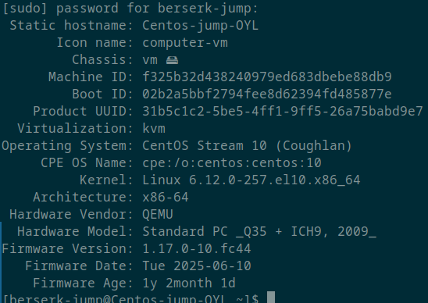

Updated system:

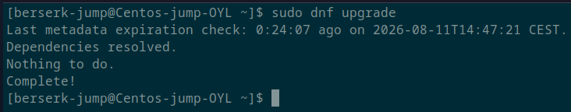
Packages installed:

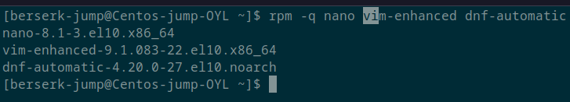

Users exist:

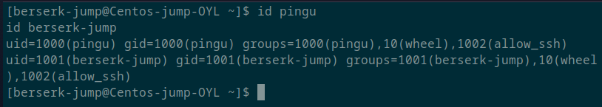

Groups & Users:

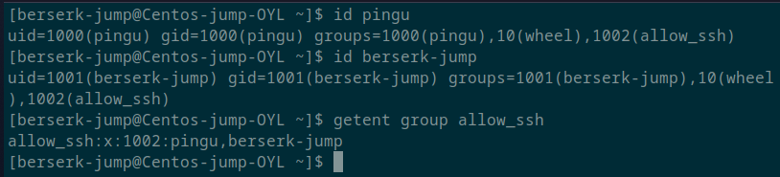

SELinux:

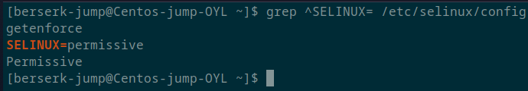

SSH:

dnf-automatic:

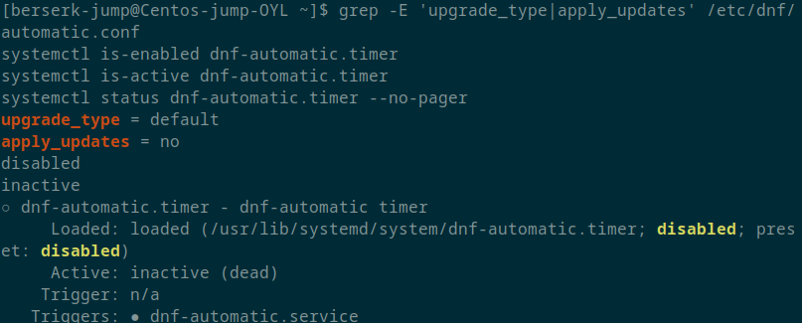

Firewall:

